LAPORAN TUGAS KEAMANAN SISTEM
INFORMATION GATHERING & RECONNAISSANCE

Nama : Mohammad Bagus Satrio
NIM : 103032400099
Target Domain :
1. telkomuniversity.ac.id
2. bpd-pwt.telkomuniversity.ac.id (subdomain)
3. io-admission.telkomuniversity.ac.id (subdomain)

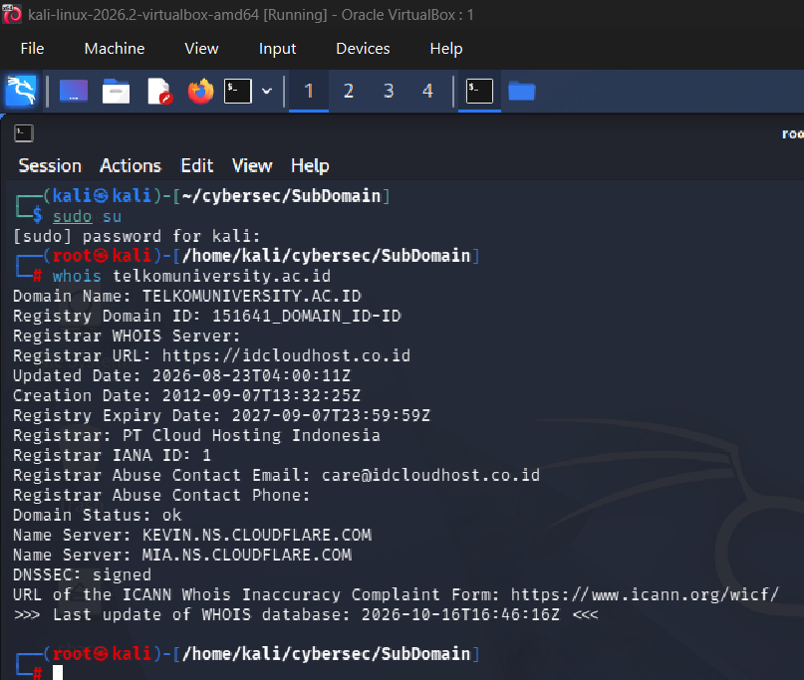

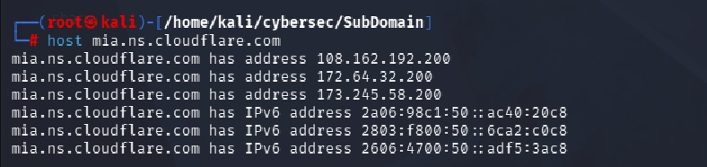

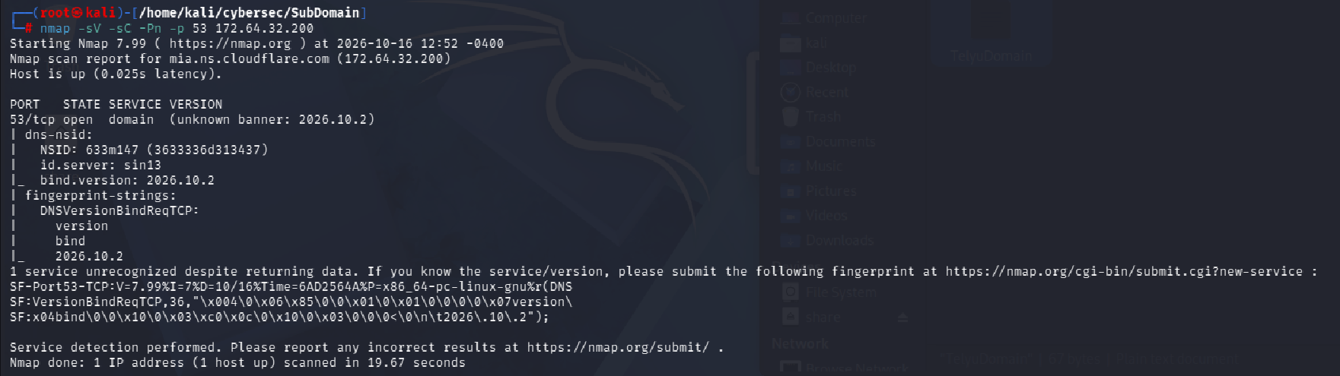
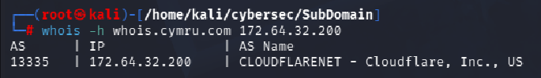

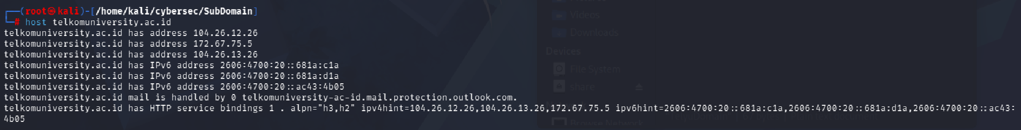
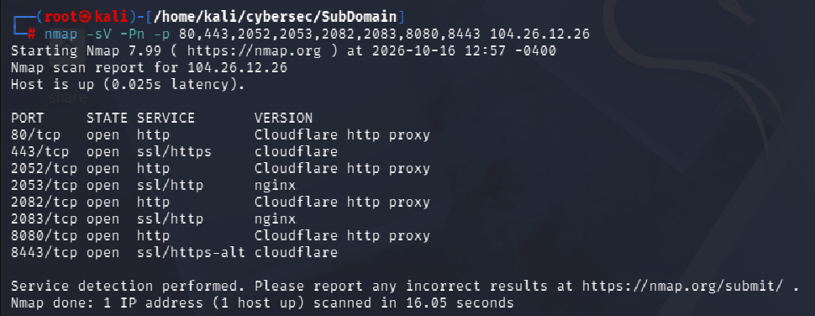
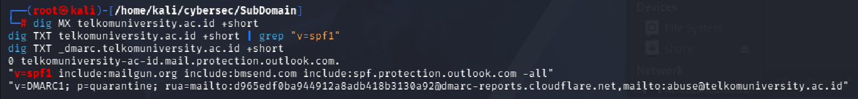

bpd-pwt.telkomuniversity.ac.id :
